Lecture 2.1.5
Solutions of Recurrence Relation using Generating Functions

Course outcome to be covered:
CO1: Apply and recognized about the Solutions of Recurrence Relation using Generating Functions

Solutions of Recurrence Relation using Generating Functions 2.1.5
Generating Function
A generating function (GF) is an infinite polynomial in powers of x where the n-th term of a series appears as the coefficient of x^(n) in the GF. Where there is a simple expression for the generating function, for example 1/(1-x), we can use familiar mathematical operations such as accumulating sums or differentiation and integration to find other related series and deduce their properties from the GF.
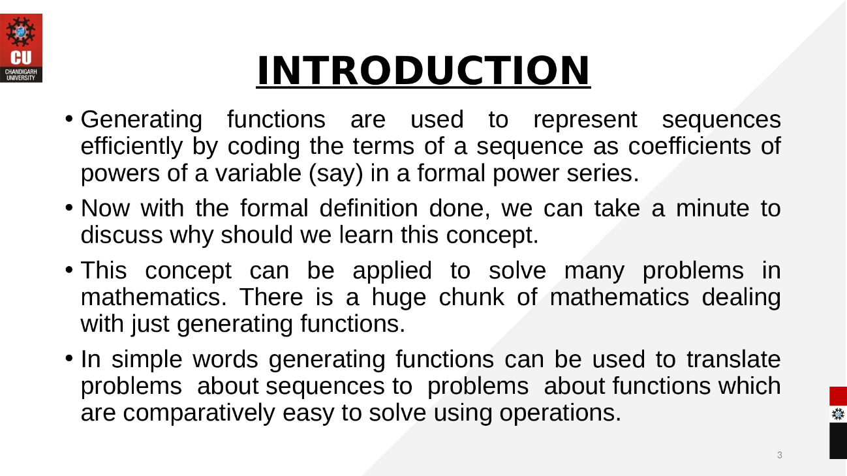
For the sequence of real numbers 𝑎0, 𝑎1, 𝑎2 … … the function 𝑮 𝒙 = 𝒂 𝟎 + 𝒂 𝟏 𝒙 + 𝒂 𝟐 𝒙 𝟐 + ⋯ = 𝒂 𝒏 𝒙 𝒏∞ 𝒏=𝟎 is called the generating function.
Example 1. For the sequence {1, 2, 3, 4, ...} the generating function 𝐺 𝑥 = 1 + 2𝑥 + 3𝑥2 + ⋯ = 1 (1 − 𝑥)2 2. Sequence: {𝑛 𝐶0 , 𝑛 𝐶1 , 𝑛 𝐶2 , … , 𝑛 𝐶 𝑛 , 0,0,0, … } 𝐺 𝑥 = 𝑛 𝐶0 + 𝑛 𝐶1 𝑥 + 𝑛 𝐶2 𝑥2 + 𝑛 𝐶3 𝑥3 + ⋯ + 𝑛 𝐶 𝑛 + 0 + 0 + 0 … = 1 + 𝑥 𝑛 + 0 + 0 + ⋯ 𝐺 𝑥 = 1 + 𝑥 𝑛
The generating function for the sequence ‘s’ with terms 𝑎0, 𝑎1, … , 𝑎 𝑛 of real numbers is the infinite sum. 𝐺 𝑥 = 𝐺 𝑠, 𝑥 = 𝑎0 + 𝑎1 𝑥 + ⋯ + 𝑎 𝑛 𝑥 𝑛 + ⋯ = 𝑎 𝑛 𝑥 𝑛 ∞ 𝑛=0
Example
The generating function for the sequence ‘s’ with the terms 1, 1, 1, 1, ........, is given by 𝐺 𝑥 = 𝐺 𝑠, 𝑥 = 𝑥 𝑛 = ∞ 𝑛=0 1 (1 − 𝑥) Problems Find the generating function for the following sequences:
1) < 20 , 21 , 22 , 23 , … 2 𝑟 >
2) < 7, −4, 3, 0, 1 >
3) < 1, 2, 3, 4 >
Procedure for solving recurrence relation using generating function
Step 1: Rewrite the recurrence relation as an equation with 0 on RHS
Step 2: Multiply the equation obtained in step 1 by 𝑥 𝑛 and summing it from 1 to ∞ (or 0 to ∞) or (2 to ∞)
Step 3: Put 𝐺 𝑥 = 𝐺 𝑠, 𝑥 = 𝑎 𝑛 𝑥 𝑛∞ 𝑛=0 and write 𝐺 𝑥 as a function of 𝑥
Step 4: Decompose 𝐺 𝑥 into partial fraction
Step 5: Express 𝐺 𝑥 as a sum of familiar series Step 6: Express 𝑎 𝑛 as the coefficient of 𝑥 𝑛 in 𝐺 𝑥

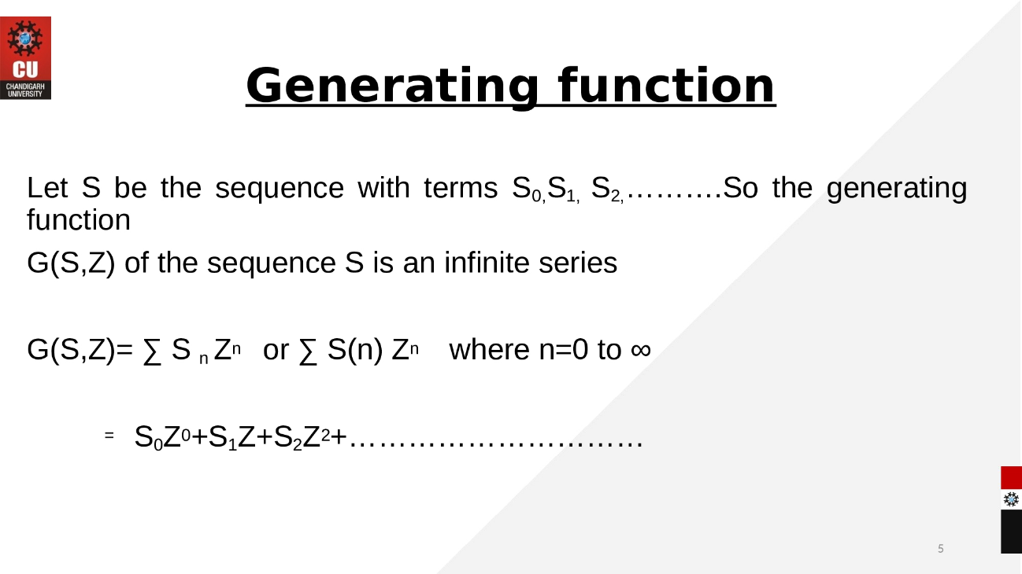
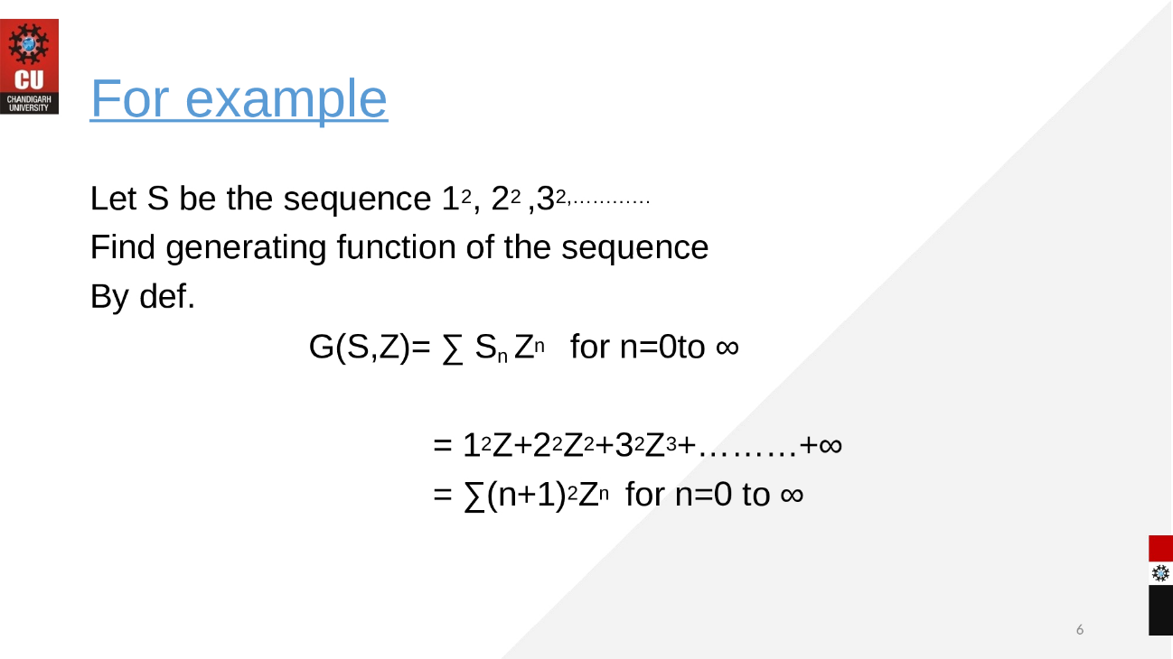

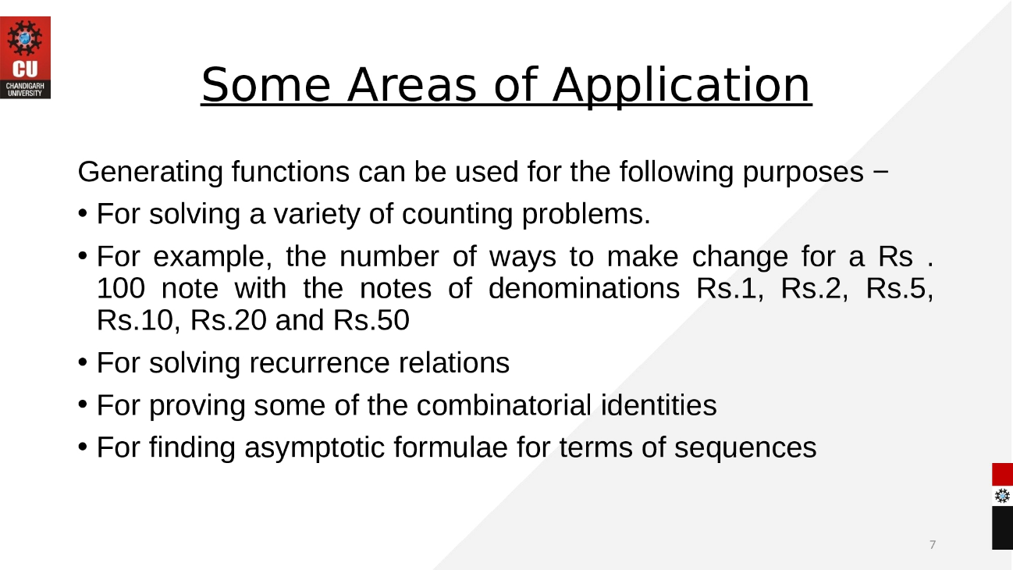
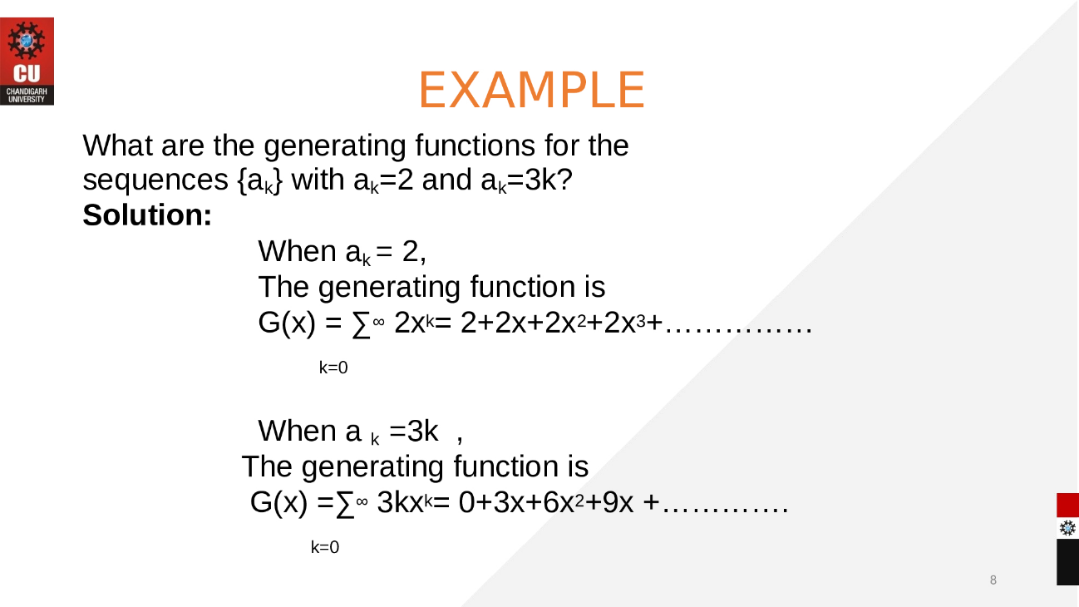
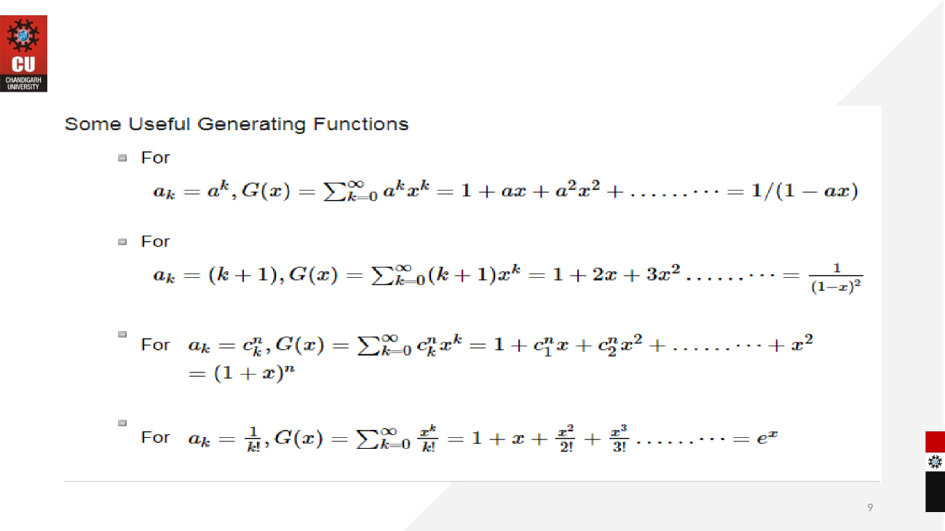
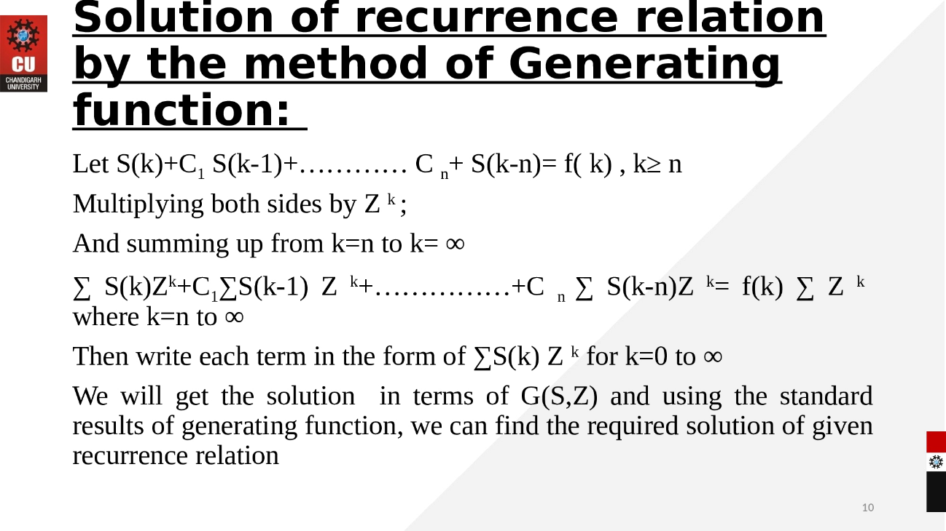
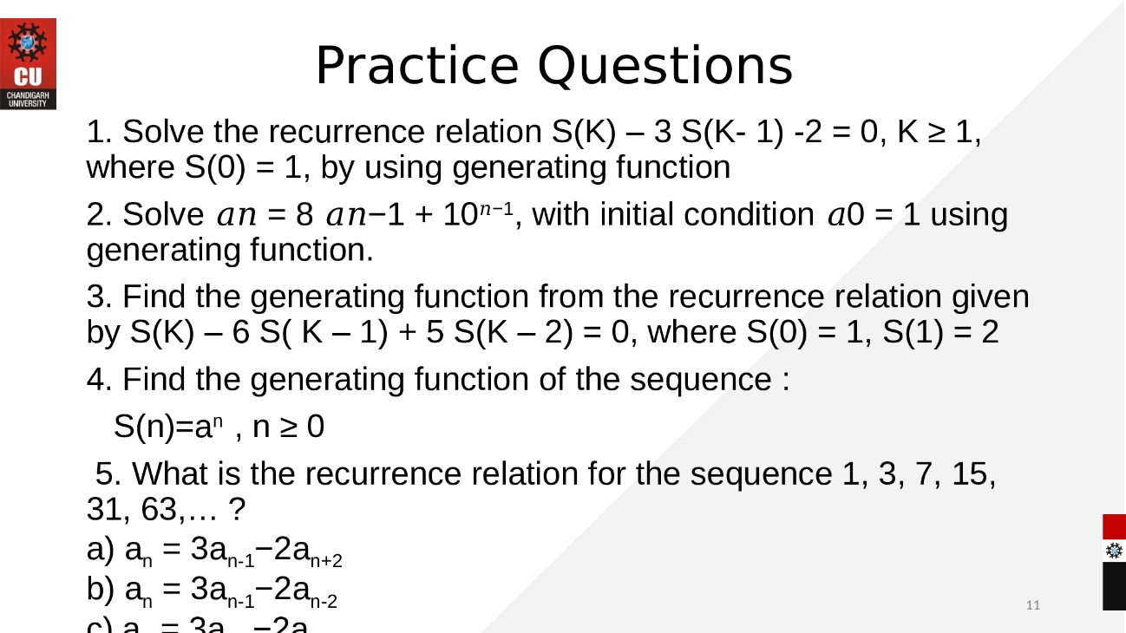

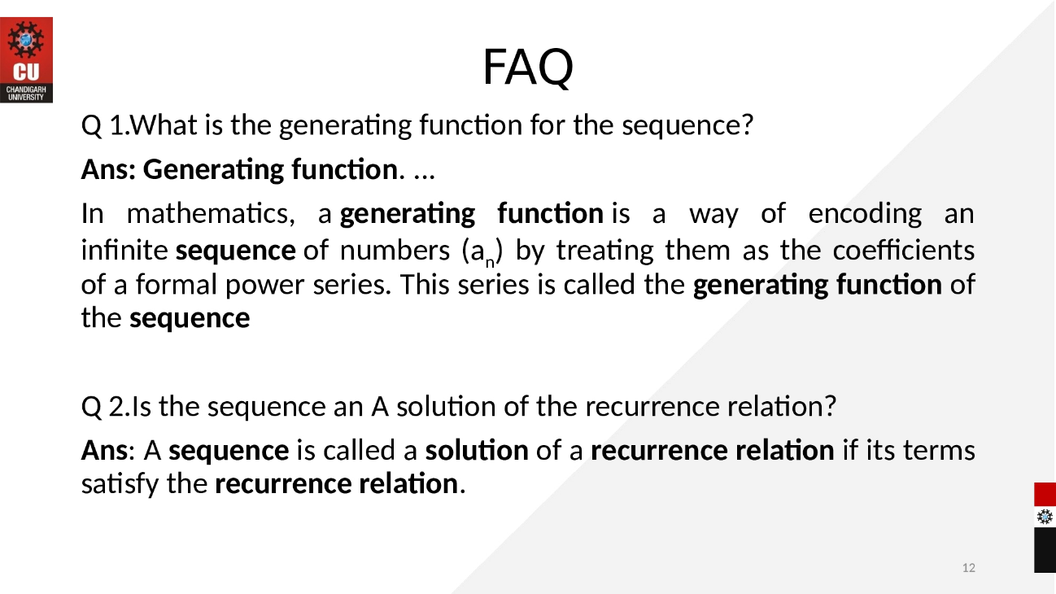
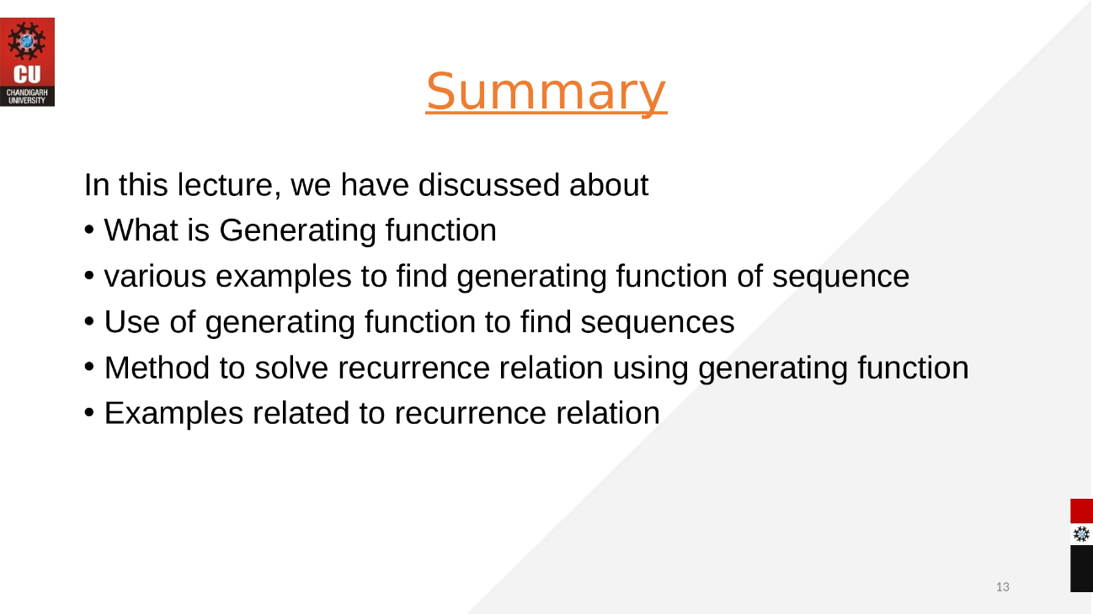
eBook Discrete Mathematics :
https://cse.iitkgp.ac.in/~animeshm/generating_funct.pdf

Video link: https://www.youtube.com/watch?v=Xf-mnh65CaU

